Homework 2-Solutions

Assigned: September 16, 2024 (Monday)
Due: September 23, 2024 (Monday)

Problem 1 Write complete pseudo code for enqueue using the incremental strategy for Array based Queue ADT with constant incremental size of c. Find the worst time complexity of your pseudo code in terms of amortized cost.
Algorithm enqueue(o):
if size() = N − 1 then
grow queue Q from current size to current_size + c
Q[r] ← o
r ← (r + 1) mod N

Amortized Complexity O(n)

Problem 2 Consider the implementation of queue ADT with stack ADT. The modified Queue has enqueue and dequeue operations implemented using stack push and pop operations as depicted below:
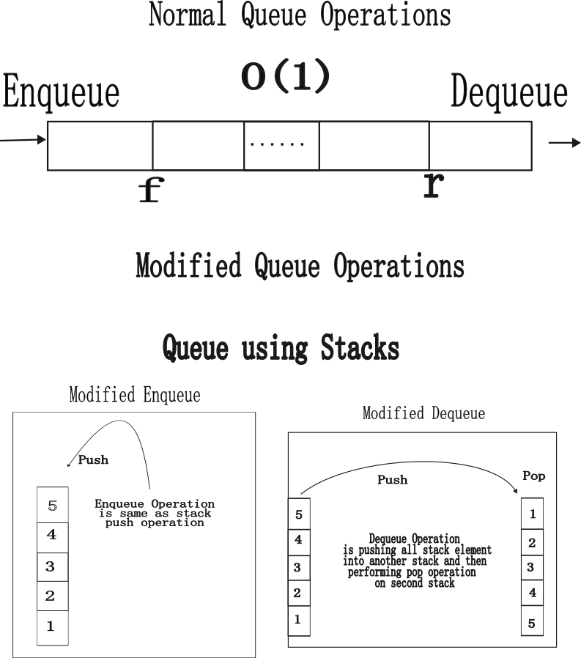

- Figure out the issue with modified Dequeue operation.
  - The queue state after dequeue operation is not correct for enqueue operation implement using stack push. For enqueue to work in O(1), the dequeue operation must push the element back into original stack after performing pop operation.
- Write the pseudocode of modified enqueue and dequeue operations.
Algorithm enqueue(o):
if size() = N − 1 then
grow queue Q from current size to current_size + c
(blue pseudo code is not required as part of answer)
pop and push into another stack
perform a pop operation
push back remaining elements back into original stack
- Analyze the time complexity of modified enqueue and dequeue operations. Make necessary assumptions if required.
  - O(1) for enqueue operation
  - O(n) for deque operation

Problem 3: Define the following terms:
- Abstract data type
- Data structure
- “The design of the data structure should be based on application and the frequency of the operations. It is ok to have costly low frequency operations as compared to high frequency operations”. Comment on the above statement.
- Why O (1) run time complexity ideal for high frequency operations. Why developers should focus on creating a data structure that enables such operations in O (1).

